**Target Business Analysis**

1. Exploratory Analysis
2. Data type of columns in a table

Customer Table

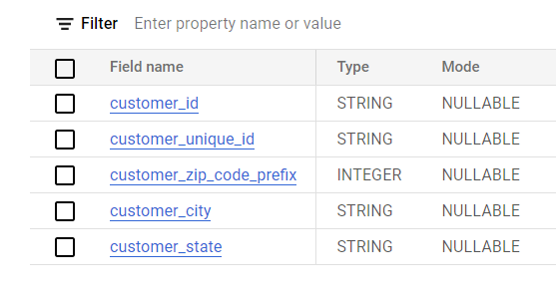

Geo location Table

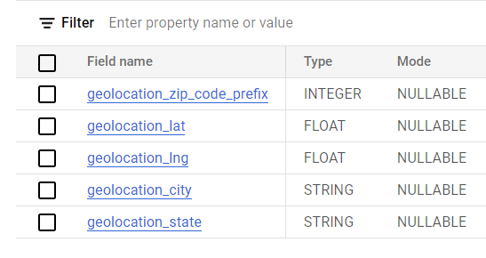

Orders Table

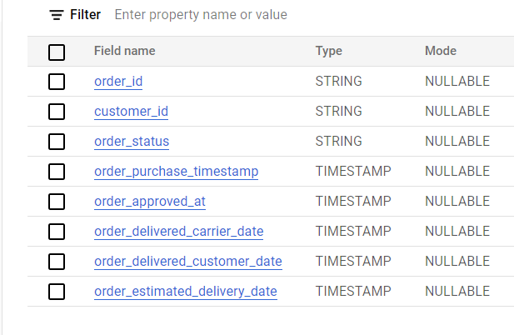

Payments Table

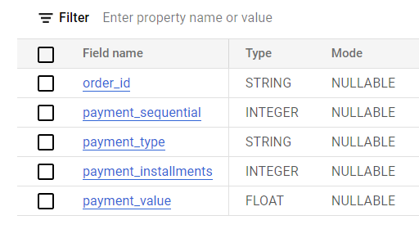

Product Table

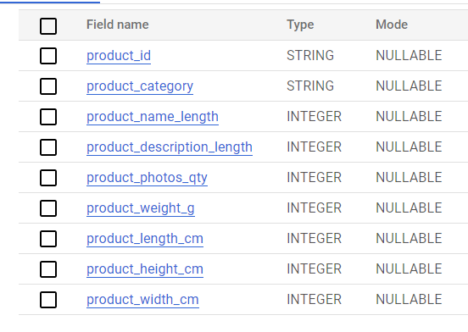

1. Time period for which the data is given

Query :

SELECT MIN(order_purchase_timestamp) as First_Order_date ,

MAX(order_purchase_timestamp) as Last_Order_date

FROM `target-project-384615.Target.orders`

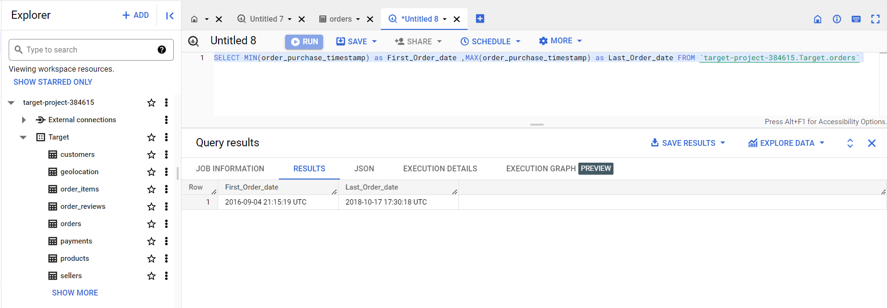

As per the output the Time period is from 4th September 2016 to 17th October 2018

1. Cities and States of customers ordered during the given period

Query:

SELECT distinct(c.customer_city),c.customer_state

FROM `target-project-384615.Target.orders` o

JOIN `target-project-384615.Target.customers` c on o.customer_id = c.customer_id;

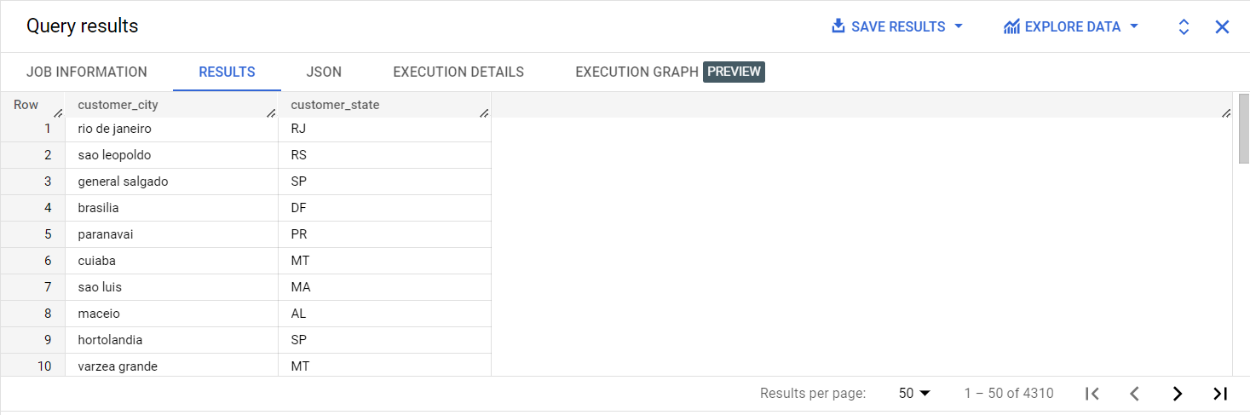

1. In-depth Exploration:
2. Is there a growing trend on e-commerce in Brazil? How can we describe a complete scenario? Can we see some seasonality with peaks at specific months?

Query :

SELECT COUNT(o.order_id) as Count_of_Orders,

EXTRACT(MONTH from o.order_purchase_timestamp) as MONTH,

EXTRACT(YEAR from o.order_purchase_timestamp) as YEAR

FROM `target-project- 384615.Target.orders` o

JOIN `target-project-384615.Target.payments` p on o.order_id = p.order_id

GROUP BY MONTH,YEAR

ORDER BY YEAR,MONTH;

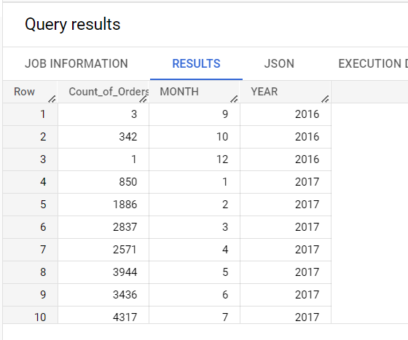

Insight : There is a rising trend in orders in 2017 , With peaks in November and December 2017.

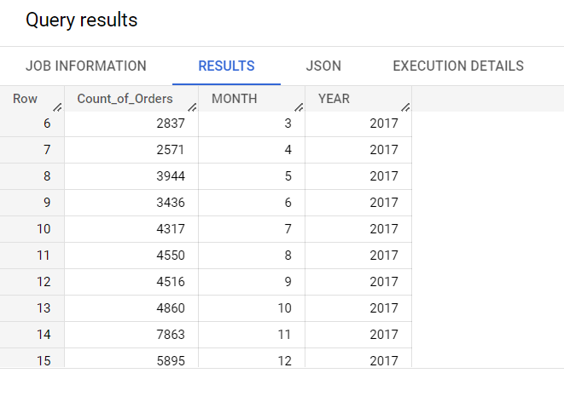

Recommendation :

1. Target must ensure that they have enough inventory to meet the increased demand during this November and December. It's important to forecast demand and adjust inventory levels accordingly. This will ensure that customers have access to the products they are looking for and will help Target to avoid stockouts.
2. Brazilian customers will be actively looking for promotions and discounts during this period. Hence Target should plan and execute targeted marketing campaigns to attract these customers. For example, promotions like free shipping or discount coupons can be offered to attract customers during this period.
3. What time do Brazilian customers tend to buy (Dawn, Morning, Afternoon or Night)?

Query :

SELECT COUNT(customer_id) as No_of_Customers,

CASE WHEN TIME(order_purchase_timestamp) BETWEEN '00:00:00' and '06:59:59'

THEN 'DAWN'

WHEN TIME(order_purchase_timestamp) BETWEEN '07:00:00' and '12:00:00'

THEN 'MORNING'

WHEN TIME(order_purchase_timestamp) BETWEEN '12:00:01' and '18:00:00'

THEN 'AFTERNOON'

WHEN TIME(order_purchase_timestamp) BETWEEN '18:00:01' and '23:59:59'

THEN 'NIGHT'

ELSE null

END as Time_period

FROM `target-project-384615.Target.orders`

GROUP BY Time_period

ORDER BY No_of_Customers desc;

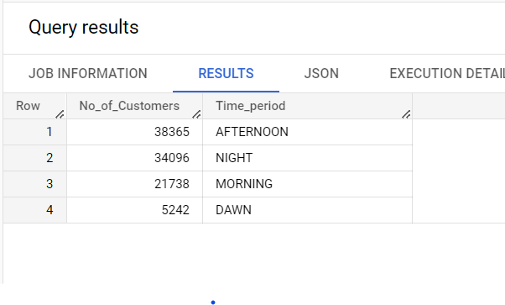

Insight : Brazilian Customers tend to buy mostly during 12pm to 6pm (AFTERNOON) and 6pm to 12am (NIGHT) being the second highest time of the day.

Recommendation :

1. Target should start advertising campaigns to reach Brazilian customers during peak buying times (AFTERNOON and NIGHT) , such as through targeted social media ads or sponsored search results on popular e-commerce platforms in Brazil.
2. Target should Offer promotions and discounts specifically targeted towards afternoon and night shoppers, such as flash sales or limited-time offers during these time periods.
3. Provide extensive customer service and support during the afternoon and night hours, as this may be when Brazilian customers are most likely to be shopping and in need of assistance. Hence enhancing Customer experience to improve Customer retention rate.
4. Evolution of E-commerce orders in the Brazil region:
5. Get month on month orders by states

Query :

SELECT c.customer_state,COUNT(o.order_id) as Count_of_Orders,

EXTRACT(MONTH from o.order_purchase_timestamp) as MONTH,

EXTRACT(YEAR from o.order_purchase_timestamp) as YEAR

FROM `target-project-384615.Target.orders` o

JOIN `target-project- 384615.Target.customers` c

on o.customer_id = c.customer_id

GROUP BY MONTH,YEAR,c.customer_state

ORDER BY YEAR,MONTH;

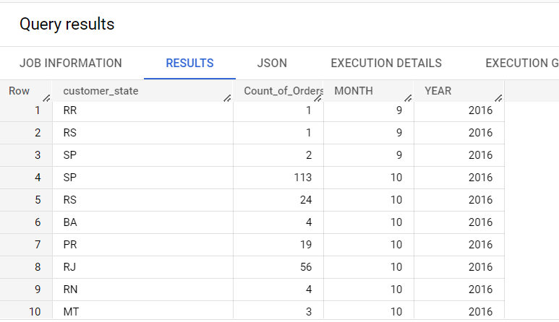

1. Distribution of customers across the states in Brazil

There are total 27 states in Brazil

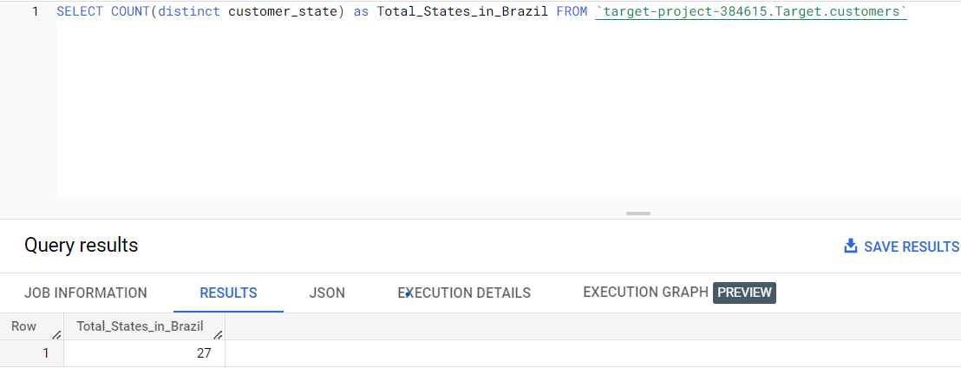

Query :

SELECT customer_state,COUNT(distinct customer_id) as Distribution

FROM `target-project-384615.Target.customers`

GROUP BY customer_state

ORDER BY Distribution desc;

Following is the distribution of Customers according to the states

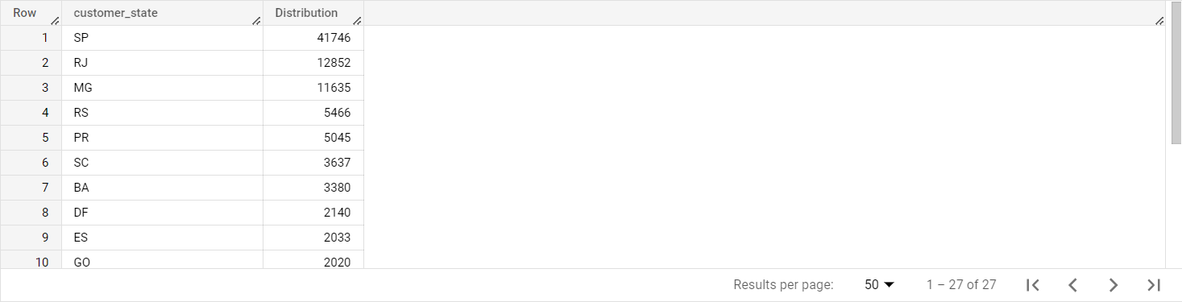

Insight : Sao Paulo , Rio de Janerio and Minas Gerais are the Top 3 states which have the most customers , with Sao Paulo which has the most customers by some margin.

Recommendation :

1. As Sao Paulo is the state with the most customers, Target could consider expanding its local presence in this region. This could include opening new stores or partnering with local retailers to increase brand visibility in the area.
2. Target should optimize its product offerings to meet the specific needs and preferences of customers in Sao Paulo. For example, they could offer products that are particularly popular or in-demand in the region, or adjust product packaging and labeling to appeal to local customers.

For eg.

Query :

SELECT COUNT(o.order_id) as Popularity,p.product_category,c.customer_state

FROM `target-project-384615.Target.products` p

JOIN `target-project-384615.Target.order_items` oi

on p.product_id = oi.product_id

JOIN `target-project-384615.Target.orders` o

on o.order_id = oi.order_id

JOIN `target-project-384615.Target.customers` c

on c.customer_id = o.customer_id

WHERE product_category is not null

GROUP BY c.customer_state,p.product_category

HAVING customer_state in ('SP')

ORDER BY Popularity desc;

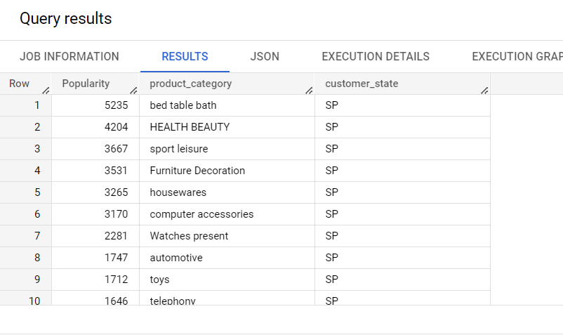

These are the most popular product categories in Sao Paulo so Target should focus on top 5 categories

1. Impact on Economy: Analyze the money movement by e-commerce by looking at order prices, freight and others -
2. Get % increase in cost of orders from 2017 to 2018 (include months between Jan to Aug only) - You can use “payment_value” column in payments table

Query :

WITH Monthly_Cost AS (

  SELECT EXTRACT(YEAR from o.order_purchase_timestamp) as Year,

         EXTRACT(MONTH from o.order_purchase_timestamp) as Month,

         SUM(payment_value) as Total_Cost

  FROM `target-project-384615.Target.orders` o

  JOIN `target-project-384615.Target.payments` p on o.order_id = p.order_id

  WHERE EXTRACT(YEAR from o.order_purchase_timestamp) in (2018,2017)

  GROUP BY Year, Month

  HAVING Month BETWEEN 1 AND 8

)

SELECT

  m1.Month,

  ROUND(m1.Total_Cost,2) as Total_Cost_2018,

  ROUND(m2.Total_Cost,2) AS Total_Cost_2017,

  ROUND(((m1.Total_Cost -  m2.Total_Cost) / m2.Total_Cost) * 100, 2) AS Percentage_Increase

FROM Monthly_Cost m1

JOIN Monthly_Cost m2 ON m1.Month = m2.Month

AND m1.Year = 2018 AND m2.Year = 2017

ORDER BY m1.Year, m1.Month;

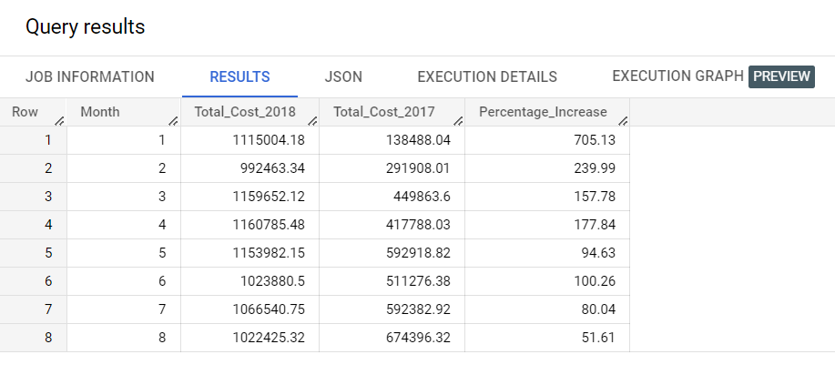

1. Mean & Sum of price and freight value by customer state

Query :

SELECT customer_state,ROUND(AVG(oi.price),2) as Mean_Price,

ROUND(SUM(oi.price),2) as Sum_Price,

ROUND(AVG(oi.freight_value),2) as Mean_Freight_value,

ROUND(SUM(oi.freight_value),2) as Sum_Freight_value

FROM `target-project-384615.Target.customers` c

JOIN `target-project-384615.Target.orders` o

on c.customer_id = o.customer_id

JOIN `target-project-384615.Target.order_items` oi

on oi.order_id = o.order_id

GROUP BY customer_state

ORDER BY Sum_Price desc;

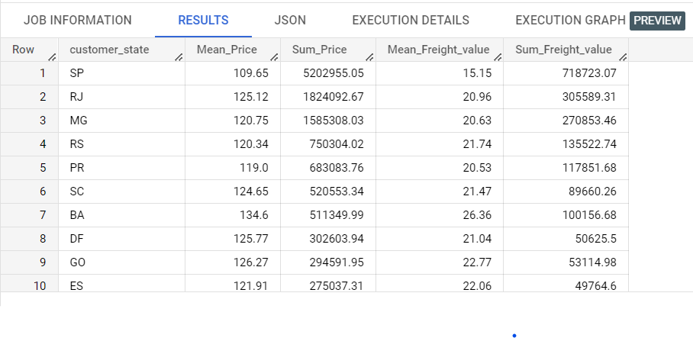

1. Analysis on sales, freight and delivery time

Query :

SELECT c.customer_state,ROUND(AVG(oi.MP),2) as Mean_Price,

ROUND(AVG(oi.MFV),2) as Mean_Freight_Value,

ROUND(AVG(DATE_DIFF(order_estimated_delivery_date,

order_delivered_customer_date,day)),2) as diff_estimated_delivery,

ROUND(AVG(DATE_DIFF(order_delivered_customer_date,

order_purchase_timestamp,day)),2) as time_to_delivery

FROM `target-project-384615.Target.orders` o

JOIN `target-project-384615.Target.customers` c

on c.customer_id = o.customer_id

JOIN (SELECT order_id,AVG(price) as MP,AVG(freight_value) as MFV

FROM `target-project-384615.Target.order_items`

GROUP BY order_id) oi on o.order_id = oi.order_id

where order_delivered_customer_date is not null

GROUP BY c.customer_state

ORDER BY Mean_Freight_Value

LIMIT 5;

1. Top 5 states with lowest average freight value

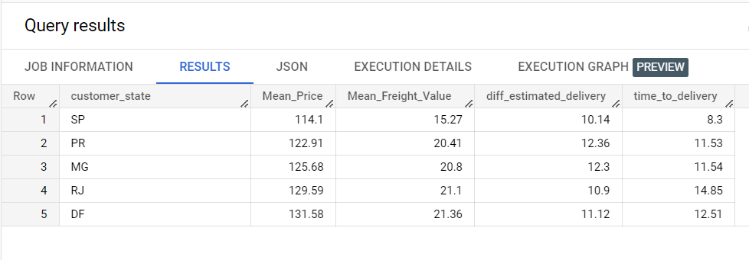

1. Top 5 states with highest average freight value

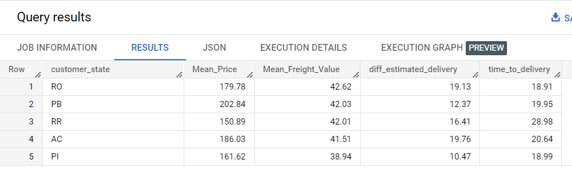

1. Top 5 states with highest average time to delivery

Query :

SELECT c.customer_state,ROUND(AVG(oi.MP),2) as Mean_Price,

ROUND(AVG(oi.MFV),2) as Mean_Freight_Value,

ROUND(AVG(DATE_DIFF(order_estimated_delivery_date,

order_delivered_customer_date,day)),2) as diff_estimated_delivery,

ROUND(AVG(DATE_DIFF(order_delivered_customer_date,

order_purchase_timestamp,day)),2) as time_to_delivery

FROM `target-project-384615.Target.orders` o

JOIN `target-project-384615.Target.customers` c

on c.customer_id = o.customer_id

JOIN (SELECT order_id,AVG(price) as MP,

AVG(freight_value) as MFV

FROM `target-project-384615.Target.order_items`

GROUP BY order_id) oi on o.order_id = oi.order_id

where order_delivered_customer_date is not null

GROUP BY c.customer_state

ORDER BY time_to_delivery desc

LIMIT 5;

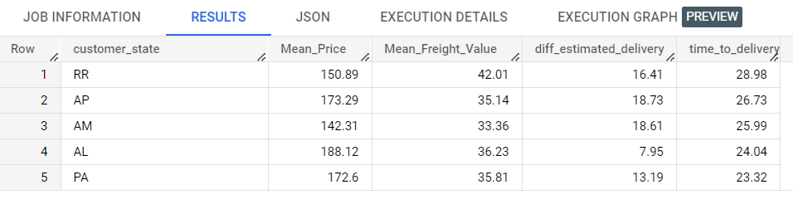

1. Top 5 states with lowest average time to delivery

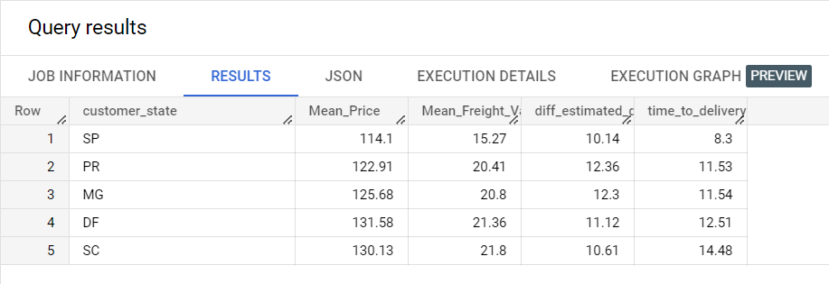

1. Top 5 states where delivery is really fast

Query :

SELECT c.customer_state,ROUND(AVG(oi.MFV),2) as Mean_Freight_Value,

ROUND(AVG(DATE_DIFF(order_estimated_delivery_date,

order_delivered_customer_date,day)),2) as diff_estimated_delivery,

ROUND(AVG(DATE_DIFF(order_delivered_customer_date,

order_purchase_timestamp,day)),2) as time_to_delivery

FROM `target-project-384615.Target.orders` o

JOIN `target-project-384615.Target.customers` c

on c.customer_id = o.customer_id

JOIN (SELECT order_id,AVG(price) as MP,

AVG(freight_value) as MFV

FROM `target-project-384615.Target.order_items`

GROUP BY order_id) oi on o.order_id = oi.order_id

where order_delivered_customer_date is not null

GROUP BY c.customer_state

ORDER BY diff_estimated_delivery

LIMIT 5;

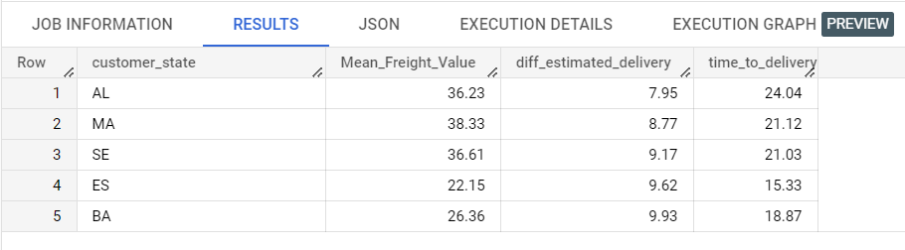

1. Top 5 states where delivery not so fast compared to estimated date

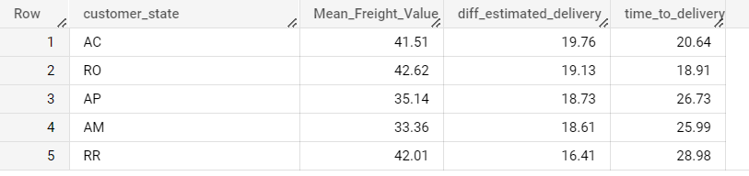

1. Payment type analysis:
2. Month over Month count of orders for different payment types

Query :

SELECT p.payment_type,COUNT(o.order_id) as Count_of_Orders,

EXTRACT(MONTH from o.order_purchase_timestamp) as MONTH,

EXTRACT(YEAR from o.order_purchase_timestamp) as YEAR

FROM `target-project-384615.Target.orders` o

JOIN `target-project-384615.Target.payments` p

on o.order_id = p.order_id

GROUP BY MONTH,YEAR,p.payment_type

ORDER BY YEAR,MONTH;

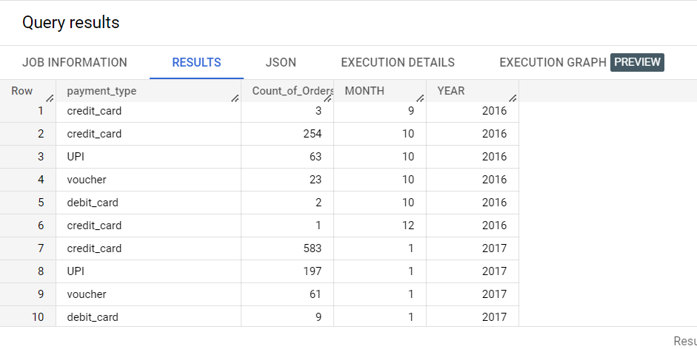

1. Count of orders based on the no. of payment installments

Query :

SELECT p.payment_installments,COUNT(o.order_id) as Count_of_Orders

FROM `target-project-384615.Target.orders` o

JOIN `target-project-384615.Target.payments` p

on o.order_id = p.order_id

GROUP BY p.payment_installments

ORDER BY p.payment_installments;

